DIGITAL SEISMOMETER with EARTHQUAKE ANALYZER
by
Marvin Joshua P. Chewchut, Clark Jay R. Cortezano, Keith Joseph B. Damandaman
Engr. Rafran Paeste de Villa

A Project Design Presented in Partial Fulfillment
of the Requirements for the Degree
BS COMPUTER ENGINEERING



CEBU INSTITUTE OF TECHNOLOGY

March 2019

DIGITAL SEISMOMETER with EARTHQUAKE ANALYZER
by
Marvin Joshua P. Chewchut, Clark Jay R. Cortezano, Keith Joseph B. Damandaman

has been approved
March 2019

APPROVING COMMITTEE:
Name of Adviser | Adviser | Engr. Rafran Paeste de Villa
Name of Panel 1 | Panel | Engr. Johnalyn Figueras
Name of Panel 2 | Panel | Engr. Rafran Paeste de Villa

ACCEPTED:

ROEL B. LAURON
Chairman
Computer Engineering Department
Cebu Institute of Technology-University
ABSTRACT

The need for a commercialized digitizer system for the earthquake detection has been the starting cause of this project. PHIVOLCS, or commonly called as Philippine Institute of Volcanology and Seismology, wishes to use this digitizer system for their sensors used to detect earth movements. This system will also be used for some buildings near the fault line. For this cause, PHIVOLCS requested to create an affordable digitizer system for their sensors.

As a pioneer project, the main objective is to create an affordable digitizer for their seismometer and create a central repository of all the acquired data. The digitizer system should be able to generate three 16 bit data from their sensor according to x, y, and z axis. Those data will be essentially combined with other data required for creating an earthquake data file. The earthquake data file follows the CSV file format and will be send over to the central repository.

ACKNOWLEDGMENTS

First of all, we’d like to thank my friends and colleagues who have supported our ideas, challenged our thinking, and helped us learn over the years. In particular, we’d like to thank Engr. Rafran Paeste de Villa and Sir Lhemar Cabrillos for teaching us how to use Android technology and guiding us in the journey of our project.

We’d also like to extend our special thanks to Engr. Johnalyn Figueras and Engr. Jovelyn Buhawe for giving us ideas and clarifications for our project.

We’d also like to extend our special thanks to Engr. Robinson Jorgio for sharing us his ideas for our project especially about amplifiers, earthquake data analyzing, and instrumentation components.

We’d also like to thank Engr. Roel B. Lauron and Dr. Chris Jordan Aliac for supporting us in our project.

Above all, we’d like to thank to CIT-U and families for providing us resources and financial assistance in the journey of our project.

Table of Contents
Page
ABSTRACT ………………………………………………………………………………………. 3
ACKNOWLEDGMENTS ………………………………………………………………………. 4
CHAPTER 1 INTRODUCTION …………………………………………………………. 7
  - Problem Background ……………………………………………………. 7
  - Project Goal and Objectives …………………………………………. 8
  - Significance of the Study ………………………………………………. 9
  - Theoretical Background ………………………………………………. 10
  - Review of Related Literature ………………………………………. 16
  - Definition of Terms ……………………………………………………. 21
CHAPTER 2 METHODOLOGY…………………………………………………………. 22
  - Block Diagram …………………………………………………………… 22
  - Project Management ………………………………………………….. 23
  - Prototype Design ……………………………………………………….. 26
  - Circuit Design …………………………………………………………….. 34
  - Program Flowchart ……………………………………………………... 36
  - Testing and Data Gathering …………………………………………. 58
CHAPTER 3 DATA PRESENTATION AND ANALYSIS ……………………………. 64
CHAPTER 4 CONCLUSION AND RECOMMENDATION …………………………. 70
REFERENCES ………………………………………………………………….................. 71
APPENDICES ………………………………………………………………………………….. 72

CHAPTER 1
INTRODUCTION

  - PROBLEM BACKGROUND

PHIVOLCS, or commonly known as Philippine Institute of Volcanology and Seismology, needs an affordable digitizer equipment for their sensors. Currently, each said equipment will not cost less than a million and it would be a problem for them to buy several pieces of it. As a response for problem, they requested some schools, including CIT University, to create and design an affordable device that will digitize their sensors.

As a response for their request, this project is created to solve the compelling problem on their digitizer equipment. We will design an amplifier for their specified sensor. The amplifier will meet the minimum and maximum frequency response and signal voltage. The signal will be feed to a digitizer circuit which is responsible for converting analog signals to digital signal. The data from the digitizer will be converted to a standard CSV file.

  - Project Goal and Objectives

- This project aims to create a cheap digitizer system as an alternative to the digitizer system used by PHIVOLCS.
- The digitizer will convert the 3-axis (x, y, and z axis) analog signal from their sensors into a 16-bit digital resolution. A file will be generated to contain primarily with digitized data, compass, time information, location, and output data speed.
- The project uses an android phone to display the digitized data while it manages the transferring of data to the cloud.
- An online database will be created to be used as a storage for all files generated by the digitizer system.
- An API will be created to be used as interface for the data stored in the cloud.
- An earthquake analyzer software will be created to serve as a backend software for analyzing data from the local database.

  - SIGNIFICANCE OF THE STUDY

As a solution to the compelling problem on PHIVOLCS digitizer, this project can become a good foundation for their goal to mass produce an affordable digitizer equipment. This can be beneficial in such a way that it will lower down the Philippine budget for buying seismic equipment. In the future when the digitizer will be completed, there will be a building code specifically for commercial and government buildings near the fault line requiring the said buildings to have a seismic sensors to be installed. This project can be used as an alternative equipment for the digitizer used by PHIVOLCS and also the sensor used by PHIVOLCS can be also be used as sensor to this project.

  - THEORETICAL BACKGROUND

The ADC (Analog to Digital Converters) in this system is composed of 2¹⁶ comparators and 2¹⁶ resistors. The Op-amp comparator compares one analog voltage level with another analog voltage level, or some preset reference voltage, VREF and produces an output signal based on this voltage comparison. In other words, the op-amp voltage comparator compares the magnitudes of two voltage inputs and determines which is the larger of the two. If the input analog voltage is much higher than the reference voltage, the comparator will output a logic high voltage. The resistors that are part of the ADC acts as a voltage divider for the reference voltage. The least significant bit comparator of the ADC module will have a low reference voltage. The higher the order of the comparator will have higher reference voltage than its lower order comparator/s. The output of the 2¹⁶ comparators will be send to the microcontroller.

The project uses online database which is the central and main repository of data in this system. In this set-up, the database is hosted by a local computer. The DBMS that will be used in this set-up is MySQL which is the Relational Database Management System (RDBMS) based on Structured Query Language (SQL). SQL Commands will be used to interact with database.

The effect of an earthquake on the Earth's surface is called the intensity. The intensity scale consists of a series of certain key responses such as people awakening, movement of furniture, damage to chimneys, and finally - total destruction. Although numerous intensity scales have been developed over the last several hundred years to evaluate the effects of earthquakes, the one currently used in the United States is the Modified Mercalli (MM) Intensity Scale. This scale, composed of increasing levels of intensity that range from imperceptible shaking to catastrophic destruction, is designated by Roman numerals. It does not have a mathematical basis; instead it is an arbitrary ranking based on observed effects.
The Modified Mercalli Intensity value assigned to a specific site after an earthquake has a more meaningful measure of severity to the nonscientist than the magnitude because intensity refers to the effects actually experienced at that place.
The lower numbers of the intensity scale generally deal with the manner in which the earthquake is felt by people. The higher numbers of the scale are based on observed structural damage. Structural engineers usually contribute information for assigning intensity values of VIII or above. There are more ways in getting the magnitude. In our case, we use the value of accelerometer in g with correlation to Modified Mercalli Intensity Scale.
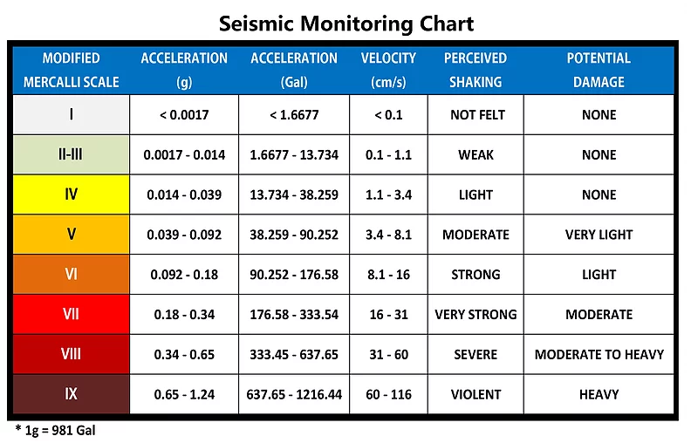
Figure 1.4.1 Seismic Monitoring Chart
The magnitude of an earthquakes can be estimated by using the formula in figure 1.4.2.
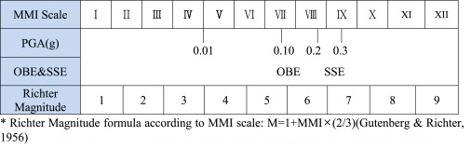
Figure 1.4.2 Richter Magnitude

In getting the direction of epicenter, it uses the concept of summing up the resultant vectors of forces using Component Method. The value of x and y will only be used. The resultant vector can be solved by first getting the sum of x and y value of digitized data by using Pythagorean Theorem. The resulting value will be then a single vector with angle in respect of x-y plane. The resulting vector of the x and y value will have a corresponding angle and magnitude. The angle of that vector will be compared with positive y plane since the three axis sensors will be positioned with respect with the poles of the Earth. The direction of the epicenter can be calculated by getting the difference of the degree of the compass of positive y-plane and the angle of the resultant vector. The angle of the resultant vector will be the subtrahend while the other one will be the minuend. 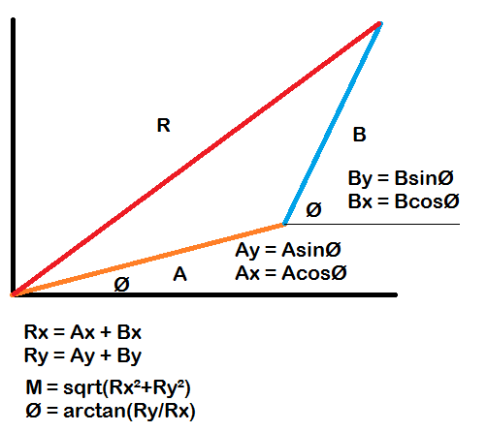
Figure 1.4.3 Resultant Vector
where:
Rx = is the resultant vector of the X-plane
Ry = is the resultant vector of the Y- plane
M = magnitude
Ø = angle

Primary waves or P waves are made up of compression waves, also known as push-pull waves. The individual waves, therefore, push against one another, causing a constant parallel, straight motion. S waves are transverse waves, which means they vibrate up and down, perpendicular to the motion of the wave as they travel. In an S wave, particles travel up and down and the wave moves forward, like the image of a sine wave. S waves are generally larger than P waves, causing much of the damage in an earthquake. Since the particles in an S wave move up and down, they move the earth around them with greater force, shaking the surface of the Earth. P waves, though easier to record, are significantly smaller and do not cause as much damage because they compress particles in only one direction.
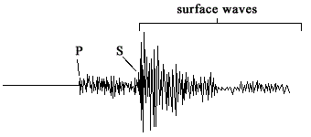
Figure 1.4.4 P and S wave
In determining the distance of hypocenter from the device, it measures the time it takes between the P – wave and the S – wave. As stated in the functional requirements of SRS, the speed of the wave to be used is 8 km/sec which is the standard speed PHIVOLCS used.
An accelerometer is an electromechanical device used to measure acceleration forces. Such forces may be static, like the continuous force of gravity (g) or, as is the case with many mobile devices, dynamic to sense movement or vibrations.
1g = 9.81 m/s²
Single- and multi-axis models of accelerometer are available to detect magnitude and direction of the proper acceleration, as a vector quantity, and can be used to sense orientation , coordinate acceleration, vibration, shock, and falling in a resistive medium. Micromachined microelectromechanical systems (MEMS) accelerometers are increasingly present in portable electronic devices and video game controllers, to detect the position of the device or provide for game input.
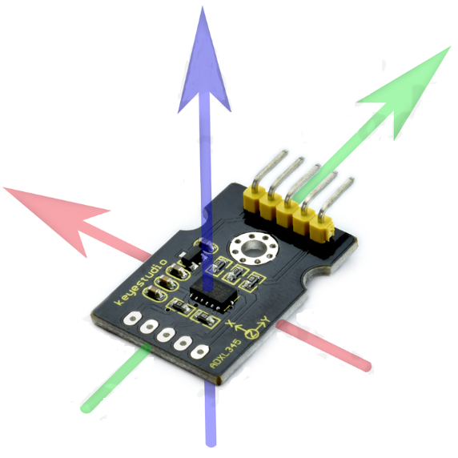
Figure 1.4.5 Accelerometer

  - REVIEW OF RELATED LITERATURE

In the project of Zhang J, et. al. entitled the Real-time earthquake monitoring using search engine method, they used a different approach of determining and analyzing earthquakes rather than the common way of using recorded seismograms to infer its location, magnitude and source-focal mechanism as quickly as possible. Here, the researchers used an earthquake search engine, similar to a web search engine, that the researchers developed by applying a computer fast search method to a large seismogram database to find waveforms that best fit the input data. The researchers’ method is several thousand times faster than an exact search. For an Mw 5.9 earthquake on 8 March 2012 in Xinjiang, China, the search engine can infer the earthquake's parameters in less than a second after receiving the long-period surface wave data.

The challenge lies in the automatic and rapid estimation of the earthquake source mechanism in a few seconds after receiving the seismic data from a few stations. The researchers developed an image-based earthquake search engine, similar to web search engines, to estimate earthquake parameters within 1 second by searching for similar seismograms from a large database on a single AMD Opteron processor 6136. Significant advances in computer search technology have helped the search industry to retrieve words, images, videos and voices from Internet-sized data sets. Similar to voice recording or a one-dimensional (1D) image, a seismogram is a graph record of the ground motion at a recording station as a function of time. It contains information about both the earthquake source and the earth medium through which the waves propagated. By assuming that the earth velocity model is known, the researchers applied a forward modelling approach to build a database of waveforms for scenario earthquakes over possible source mechanisms and locations on a discretized grid. The researchers’ objective was to find the best matches to any new earthquake record from the database. This approach is fully automatic and requires no parameter input or human interference. Therefore, it could be applied for routinely reporting earthquake parameters.

After some test in their test area of 5° by 5° in Southern Xinjiang, China, where three permanent seismic stations that can record earthquakes from the area within a range of ~5° to 15°, the researchers’ methods were proved correct after an earthquake hit Xinjiang, China back in 2015. On the other hand, our project is more focused on finding the general direction and maximum amplitude generated on the sensor using our own data collected at real time. Basically, the two project’s goals were the same but the methods to achieve it was different because the Earthquake Analyzer Project uses the traditional method of detecting the P-wave and the S-wave first by depending on a certain threshold, then calculating the magnitude of the earthquake through a formula, then finding the direction through summing up the resultant vectors of forces using Component Method.

Another project related to the Earthquake analyzer project is the project of Martin Pavelek, entitled Digitizer firmware for fast Phenomena. It is related to the Earthquake analyzer project because both of them are digitizer devices. In various applications, it may be required to detect and measure phenomena occurring on a timescale in the order of mere milliseconds or even nanoseconds. One such application may be a device for seismologist where the device reads seismic behaviors of the earth’s crust or another one may be a system for nuclear spectrometry in mixed radiation fields, where it is necessary to determine the type of each particle as it is detected. A suitable scintillation detector may be used for this application, producing a slightly different response in collisions with different types of particles. The signal from a scintillation detector typically lasts less than 100 ns, requiring appropriate equipment capable of sampling and processing such signals with reasonable precision to be used. There is already an existing device capable of achieving the needed requirements mentioned above. It is the FD-11 ŠOHAJ is a digital spectrometric system that uses a fast and precise A/D converter with a sample rate up to 2 GHz, 12 bit resolution and implements the particle characterization procedure in VHDL, using a Virtex-6 FPGA. The goals of this work are to improve its original FPGA firmware in order to increase its maintainability and to implement new features that are required to allow two A/D converters to be used simultaneously.

The digitizer device in question is first introduced in the context of the spectrometric system and the basic building blocks are described. Before designing a new data processor structure, obsolete development code was removed and changes towards better code clarity and dual - ADC support were made in the top-level entity. Various modules were modified or newly implemented in order to improve the performance or add new features to the digitizer. Both the configuration and the output interfaces were modified to support the new features and data outputs available.

The finalized firmware is ready to work with both A/D converters, supports online processing and due to improved trigger sensitivity allows to capture pulses with lower amplitude than previously possible.

In one of the process of the output, one of the trouble the project has encountered was that particles present in the measured field may cover a very wide range of energies. In case the detector assembly is set to high sensitivity, particles with low energy will produce a relatively strong signal that is easy to measure with a decent precision. In order to measure particles with higher energy, the sensitivity must be lowered, otherwise the signal could exceed the range of A/D converter and become saturated. Lowering the sensitivity makes it possible to measure particles with much higher energy, but it also means that the signal produced by low energy particles becomes much smaller. This weak signal will be in turn more susceptible to noise and only a relatively small part of the full ADC range can be used for its representation, leading to lower measurement precision of low-energy particles as the detector sensitivity decreases. Thankfully the signal received from the sensor is typically available in two channels with different amplification levels: one suitable for high energy particles and the other to preserve the precision of weak signals. By combining these two signals, a new signal can be created that helps to achieve higher dynamic range without negatively impacting the measurement precision in the region of low energies.

In the case of the Earthquake analyzer project, the accelerometer with the scale of ±3g, the output will be amplified by a PGA or programmable gain amplifier. So, if ever the output voltage of the accelerometer will be too high, the gain will be reduced to protect the ADC from over voltage and if it’s too low, the output will be amplified.

The offline data processing of Martin’s project does not actually involve any additional processing except for reassembling the raw data samples in a form that is suitable for later network transfer where as in the Earthquake analyzer project, as the name itself, after the analog data is converted into digital, it is sent into an online database and there is a C# program that will analyze its result.

In conclusion, the purpose of Martin’s project was solely an analog to digital converter and send it to a local database where as the Earthquake Analyzer Project also has analog to digital converter but it analyzes the data that it receives from the sensors it is connected to.

  - DEFINITION OF TERMS

ADC (Analog to Digital Converter) - is a component used for this project to convert analog signals from the sensor to its digital form.

UART (Universal Asynchronous Receiver-Transmitter) - is an interface that uses asynchronous serial communication between peripherals.

SPI (Serial Peripheral Interface) - is an interface that uses synchronous serial communication between peripherals.

RTC (Real Time Clock) - is a module used for getting time or date information.

GPS (Global Positioning System) - is a satellite-based radionavigation system owned by the US government and operated by the United States Air Force.

USB VCOM (Universal Serial Bus Virtual Communication Port) - is a composite Universal Serial Bus device class. The class may include more than one interface, such as a custom control interface, data interface, audio, or mass storage related interfaces. USB VCOM is one of the common communication protocol used for communicating Android devices with other devices.

CHAPTER 2
METHODOLOGY
  - BLOCK DIAGRAM

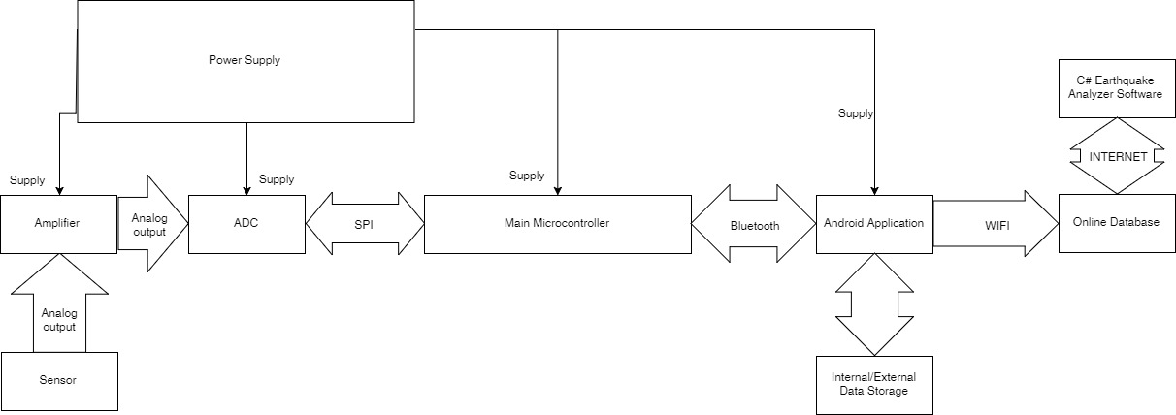

Figure 2.1 System Architecture

The major components of this system are the following: Microcontroller, ADC, RTC, and Android Phone. All the connections or interfaces are defined in the above diagram. The GPS and RTC module is already incorporated to the Android Phone. Generated data from the system will be sent to an online database via WIFI. The online database will be host by PHIVOLCS. A power supply will power-up the major components. The connection of internal/external data storage is already implement by the Android phone.s

  - PROJECT MANAGEMENT

    - Materials and Resources

Converting a single axis into 16 bits resolution includes three components namely: ADC, Microcontroller for buffer, and, amplifier. These components have each respected function. Amplifier is used for amplifying small signals generated by the sensor. The microcontroller act as buffer for the converted data from the ADC. This microcontroller is also responsible for transferring data to the primary microcontroller.

Material/Resource | Quantity | Cost
ADC | 3 | 400
Primary microcontroller for data transfer | 1 | 300
Android phone | 1 | 5000
Online Database | 1 | 15K
Power Supply | 1 | 1500
Total Cost |  | 23000

Table 2.2.1.1 Materials and Resources

    - Gantt Chart

TASK | MONTH | JULY |  |  |  | AUGUST |  |  |  | SEPT |  |  |  | OCT
TASK | WEEK | 1 | 2 | 3 | 4 | 1 | 2 | 3 | 4 | 1 | 2 | 3 | 4 | 1 | 2 | 3 | 4
Research Study
Project Proposal
Feasibility of Project
SRS: Chapter 1 Introduction
  - Purpose
  - Scope
  - Project Constraints and Limitation
  - Hardware
  - Software Requirements
  - Definition of Terms
References
Chapter 2 System Analysis
2.1 System Architecture
  - 2.2 Flowcharts
Chapter 3 Functional Requirement
Chapter 4 User Interface
Chapter 1 Introduction
  - Problem Background
  - Project Goals & Objectives
Significance of the Study
  - Theoretical Background
  - Review of Related Literature
  - Definition of Terms
Chapter 2 Methodology
2.1 Block Diagram
2.2 Project Management
  - 2.3 Prototype Design
  - Circuit Design
  - Program Flowchart
Test and Data Gathering
  - Compilation of Documents
Presentation/Defense

Table 2.2.2.1 Gantt Chart Research and Design phase

Task | Nov |  |  |  | Dec |  |  |  | Jan
Task | 1 | 2 | 3 | 4 | 1 | 2 | 3 | 4 | 1 | 2 | 3 | 4
Research about what Resources to use
for the required structure of the project
Downloading the needed resources
for the program
Setting up xml in Android for the needed UI for the user
Programming for Compression
Programming for Compass
Programming for Realtime
Programming for Upload Services
Programming for Background Services
Programming for Saving Data File
Creating and Setting up Database
Creating Tables for Database
Programming PHP for API
Designing UI for Windows form Application
Programming for Decompression
Programming for WebRequest
Programming for Json Decoding
Testing for Connectivity from
Android to Server to C#
Optimization of the code
Increment 1

Table 2.2.2.2 Gantt Chart Implementation phase

  - PROTOTYPE DESIGN

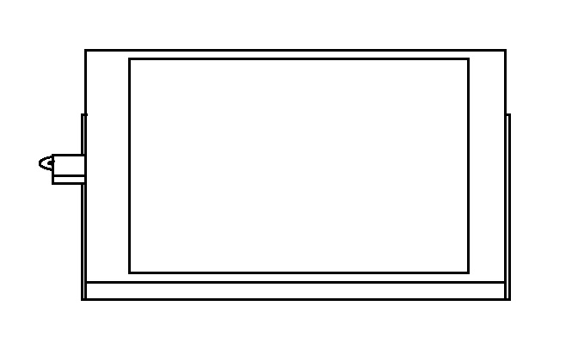

Front View

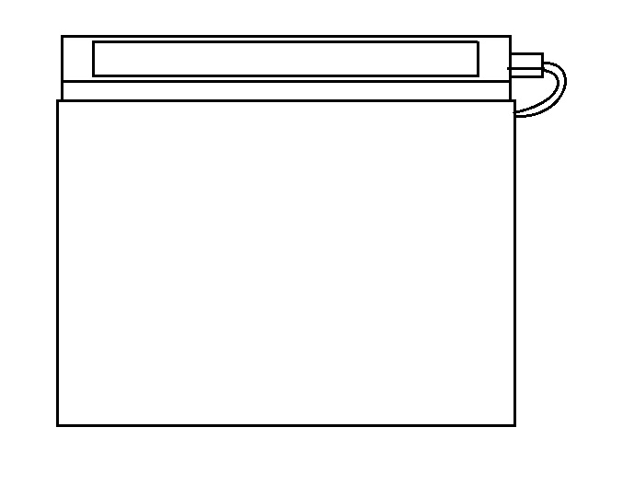

Top View

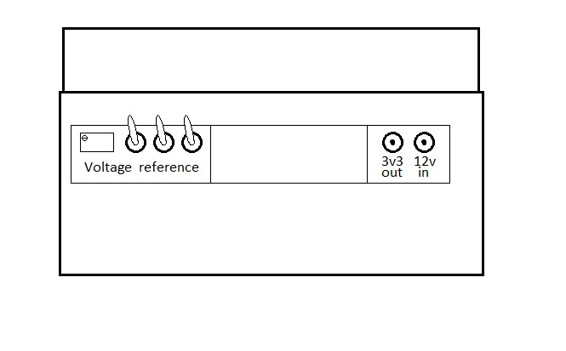

Back View

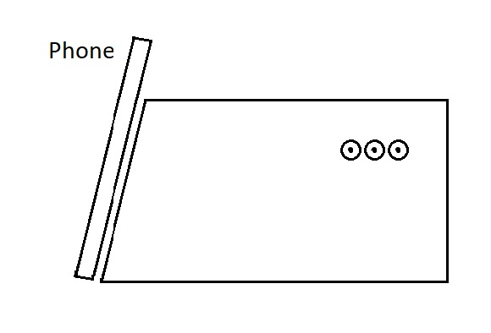

Left View

Figure 2.3.1 Prototype Design

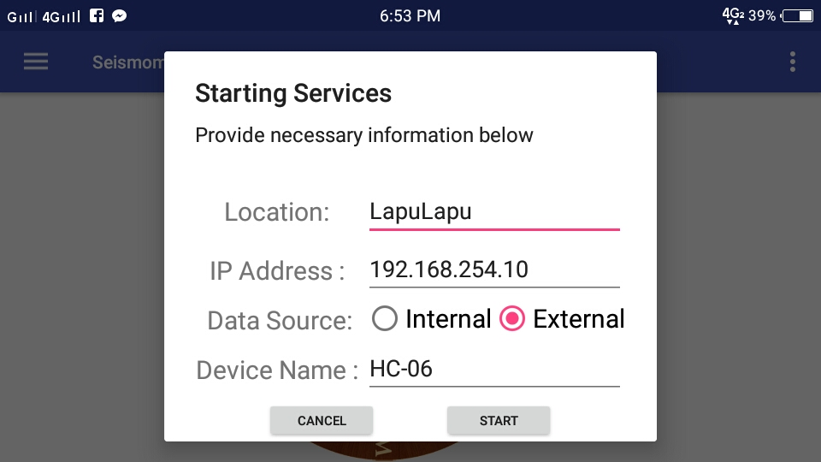

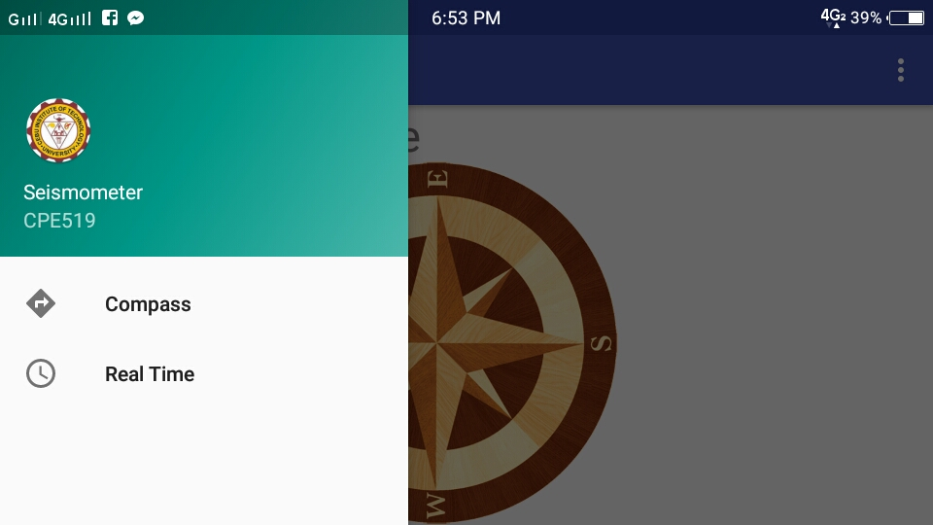

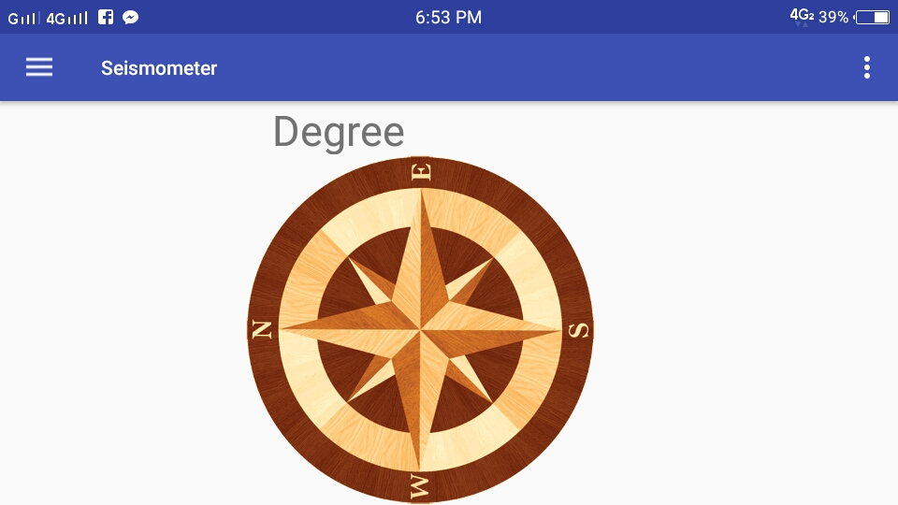

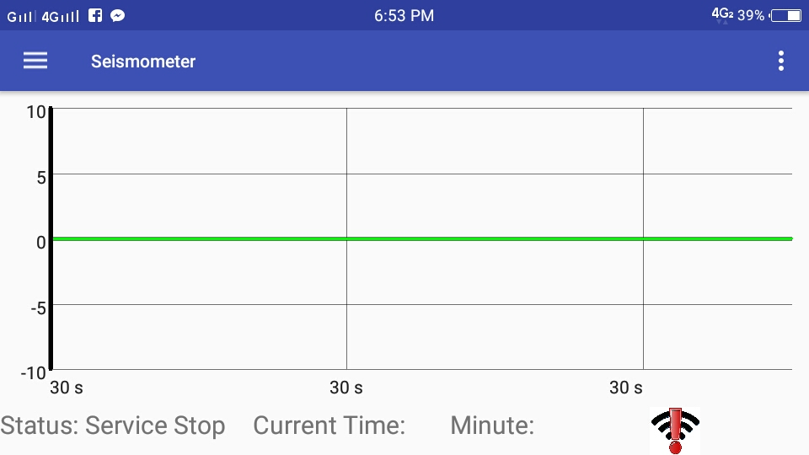

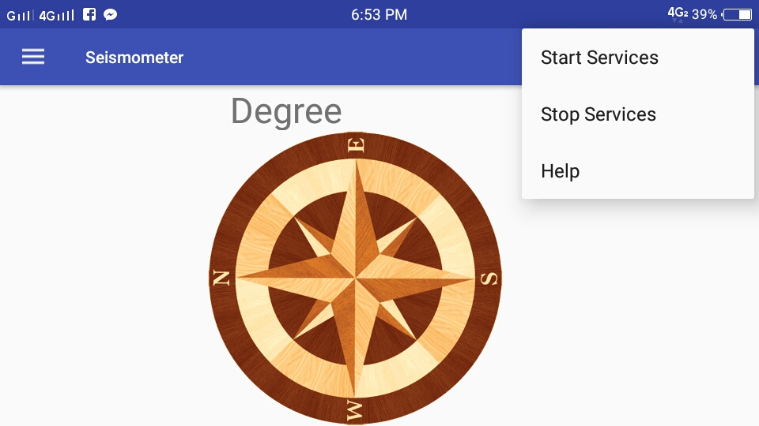

Figure 2.3.2 User Interface

In Figure 2.3.1, the prototype of the design is shown. The top view of the design shows the board where it houses the circuit of the system. The green component represents the main microcontroller. The blue component represents the android phone. In the left side view, the input port of the accelerometer is shown. While in the right-side view, the power port and the power switch is shown. In Figure 2.3.2, the GUI is also shown above. The first screen shows when the user start the application. This screen prompts the user to input the necessary information for starting the service. As seen on this screen, default values were already inputted, in case, the user doesn’t know what to put. The second screen pertains to the menu in order to traverse to other views. The menu contains two views which is the compass and real time view. Compass view, see on screen 3, displays the compass information which can be used to get information of where is the North Pole. Real Time view, see on screen 4, displays the real time data from specific source. Real Time view also displays information on connection status on WI-FI and external device when user selected the external data source mode. Lastly, Screen 5 displays a options menu where the services can be manually stop and start, and can also view help.

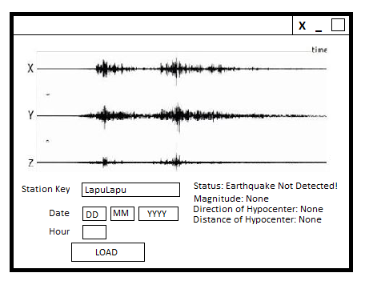
Figure 2.3.3 Earthquake Analyzer Interface

Figure 2.3.3 shows the user interface for the Earthquake Analyzer software. The user will be asked to input a station key, date, and hour of the file that the user wanted. When the user click “Load”, the software will request the file though API.

  - CIRCUIT DESIGN

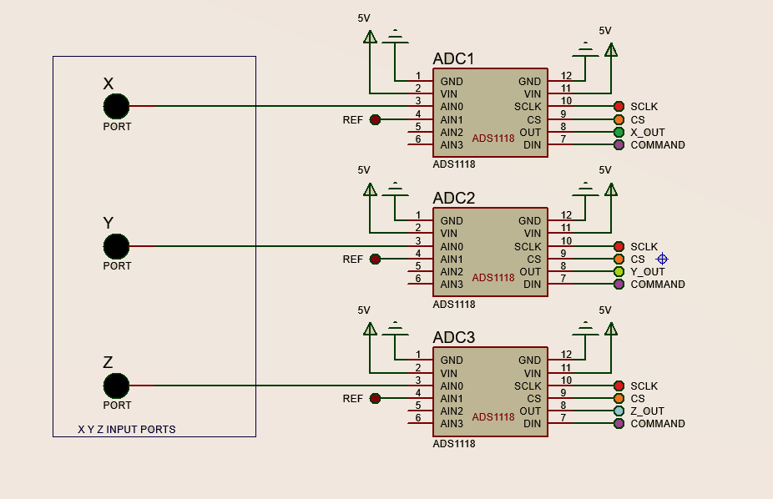

Figure 2.4.1 ADC Circuit Design

The ADC circuit design is shown on figure 2.4.1. This circuit is controlled only by one microcontroller. The ADC then converts the incoming signals from the sensor into 16 bit digital resolution. The output of the ADC is being fed to the microcontroller through SPI interface. The microcontroller then send the data to Android through Bluetooth. All SCLK (Synchronization Clock) pins of ADCs are common to each other, the same goes with CS (Chip Select) and Command pins.

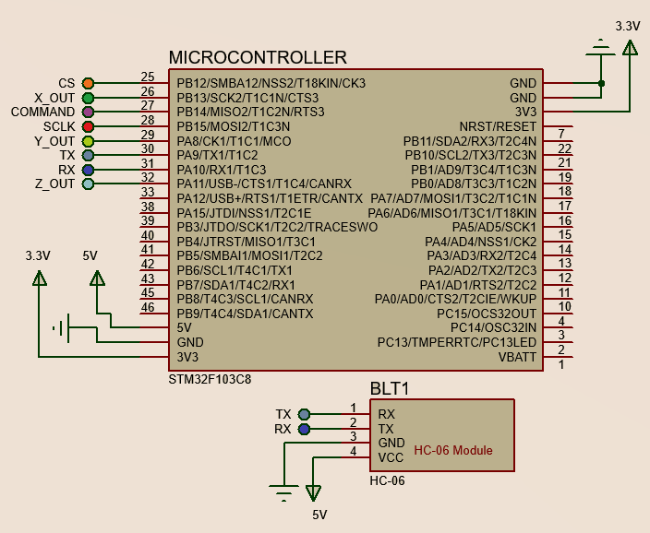

Figure 2.4.2 Main Controller Design

The main controller circuit is shown in this figure 2.4.2. The microcontroller shown in this figure is the main microcontroller of the system. Data from all ADC are received by this microcontroller.. The communication between android and main microcontroller is through Bluetooth.

  - PROGRAM FLOWCHART
    - General Flowchart
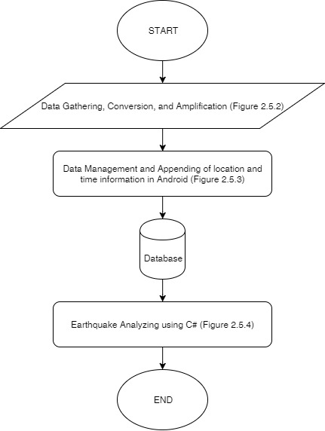
Figure 2.5.1 General Flowchart
Figure 2.5.1 shows the general flowchart of the system. This describes the overall flow of the system from data gathering until C# back end software of the system.

    - Data Gathering, Conversion, and Amplification

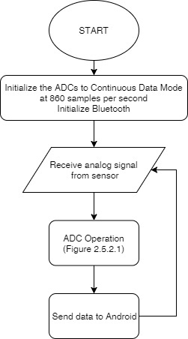
Figure 2.5.2 Data Gathering, Conversion, and Amplification
This figure shows the general flowchart of data gathering, conversion, and amplification. Sub flowcharts, figure 2.2.2.1 and 2.2.2.2, will be shown below.

      - ADC Operation

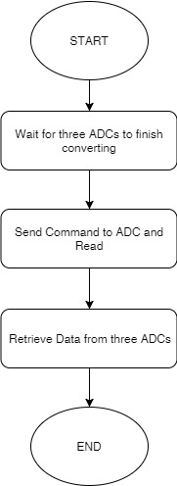
Figure 2.5.2.1 ADC Operation
The ADC module is controlled by the microcontroller which is responsible for data acquisition request. The figure above shows the flowchart of data acquisition of the microcontroller.

    - Data Management and Appending of location and time information in Android

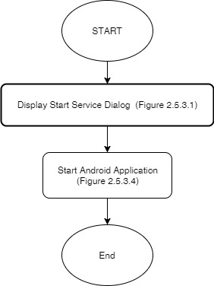
Figure 2.5.3 Android Software General Operation
The figure above shows the general operation of the android software. The Android software is responsible for appending time and location information to the received raw data, creating back-up, sending data to an online database, and displaying the data in a graphical form using Android phone. The process above shows that it will prompt a dialog box that will ask information from user for starting the services. After these necessary actions, It will start the services together with user interface.

      - Display Start Service Dialog

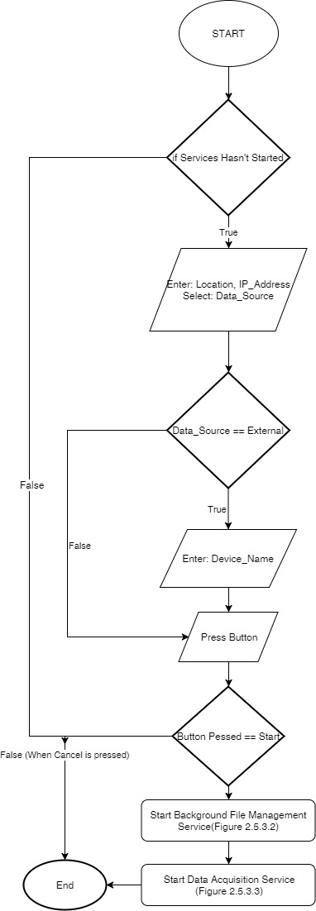
Figure 2.5.3.1 Display Start Service Dialog
The figure above shows the flowchart of dialog box during start-up. This dialog box will ask information from user for starting the necessary services.
      - Background File Management Service

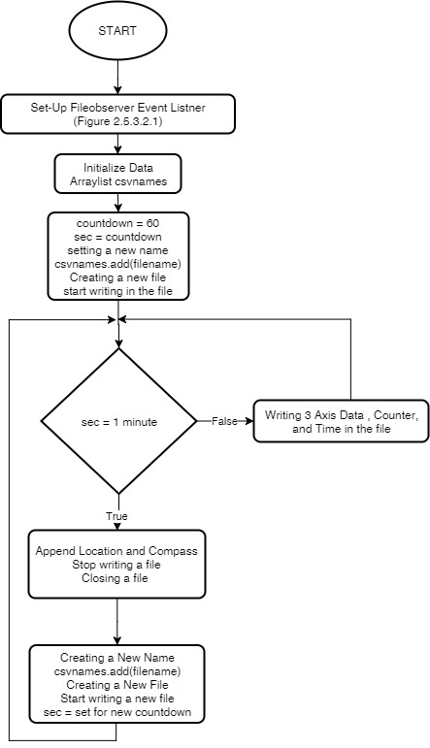
Figure 2.5.3.2 Background File Management Service
The figure above shows the flowchart of background file management service. The purpose of this service is to create and manage csv file. It will automatically produce zip file version of csv files and send it to the database. The service is using File Observer class which is used to listen changes of the subfolder.
        - Set-Up File Observer Event Listener

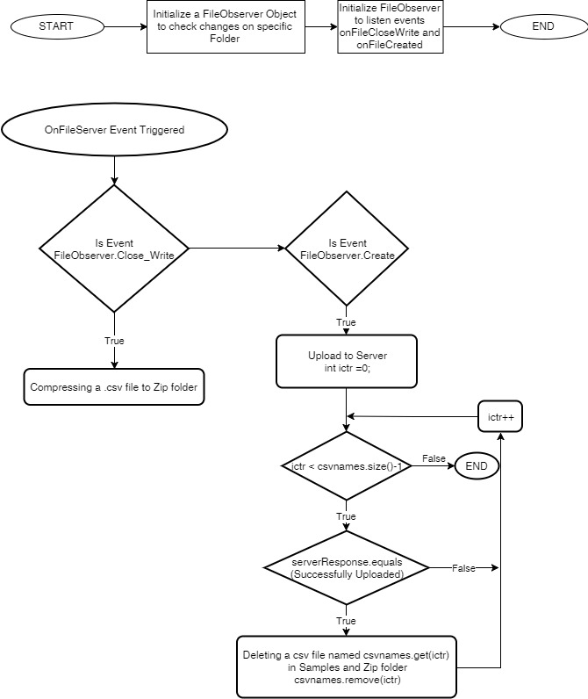
Figure 2.5.3.2.1 Set-up File Observer Event Listener
The figure above shows the flowchart of initializing the listener and actions taken when the event is triggered. The File Observer is very useful on checking changes on the specified folder rather than polling the changes.
      - Data Acquisition Service

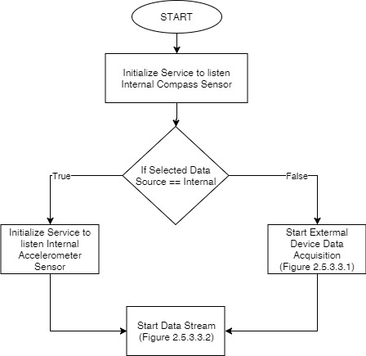
Figure 2.5.3.3 Data Acquisition Service
The figure above shows the general flowchart of data acquisition service. The service purpose is to listen data from internal or external sensor and broadcast the data in order for activity and services to receive the data. It will send notification when connection is lost or gain and the source of data.

        - External Device Data Acquisition

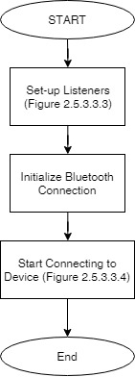
Figure 2.5.3.3.1 External Device Data Acquisition
The figure above shows the general flowchart of external device data acquisition service. The service purpose is to listen data from external sensor and broadcast the data in order for activity and services to receive the data. It also reconnects to the said external device during loss of connection. It will send notification when connection is lost or gain.

        - Data Stream

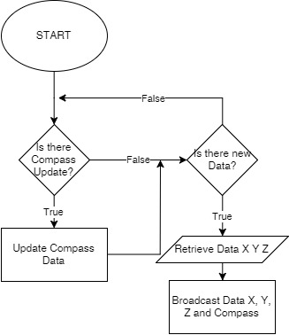
Figure 2.5.3.3.2 Data Stream
The figure above shows the flowchart of data streaming. The purpose of this functionality is to broadcast data from internal or external sensor. The data contains compass, x, y, and z values.

        - Setup Listeners

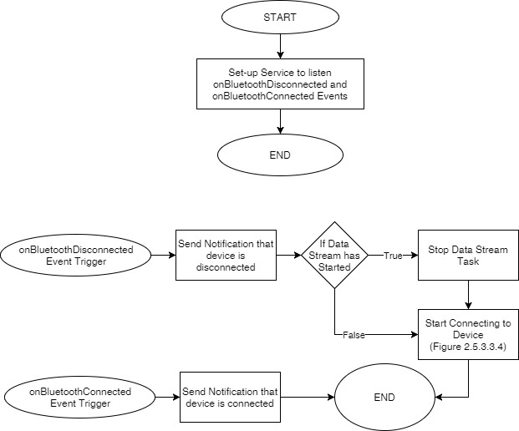
Figure 2.5.3.3.3 Setup Listeners
The figure above shows the flowchart during listener set-up. The functionality only triggers when user selected the external data source mode. The purpose of this function is to listen events on changes of Bluetooth connection state and do appropriate actions.

        - Connecting to Device

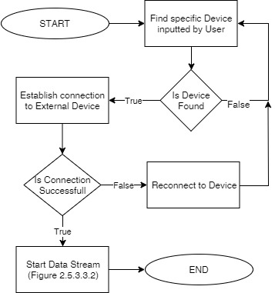
Figure 2.5.3.3.4 Connecting to Device
The figure above shows the flowchart during connecting to external device. This functionality only triggers when user selected the external data source mode. It uses the information from the device name inputted by the user.

      - Android Application
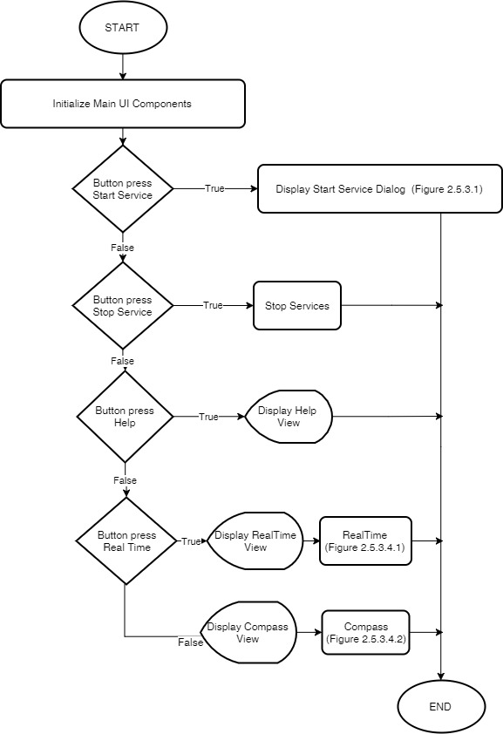
Figure 2.5.3.4 Android Application
The figure above shows the flowchart after the user inputted the necessary information for starting the service. This flowchart describes the main user interface of the android application.
        - Real Time

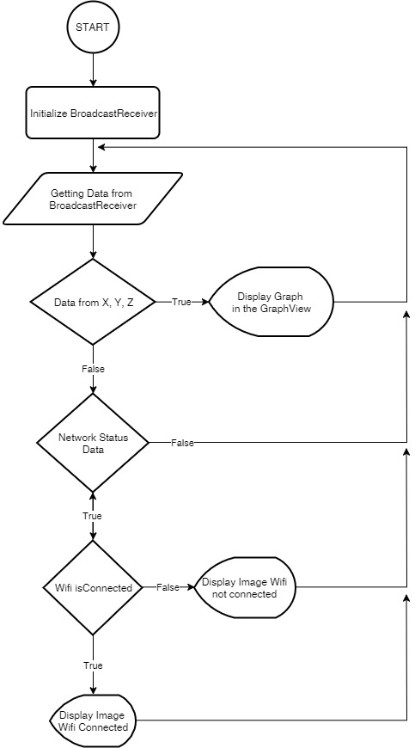
Figure 2.5.3.4.1 Real Time
The figure above shows the flowchart of Real Time user interface. The purpose of this interface is to display the data in graph form and the connectivity status.
        - Compass

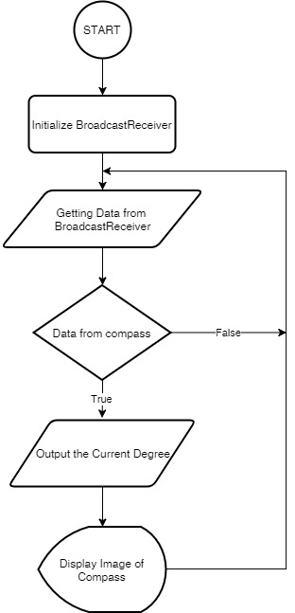
Figure 2.5.3.4.2 Compass
The figure above shows the flowchart of Compass user interface. The purpose of this interface is to display the compass data using an image and animate according to the direction of North Pole.
    - Earthquake Analyzing using C#

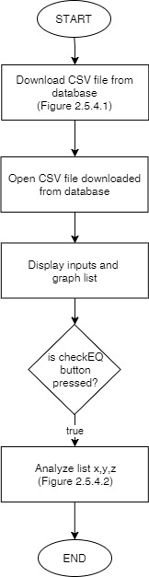
Figure 2.5.4 General Flowchart of Earthquake Analyzer
The figure above shows the general flowchart of earthquake analyzer. The Earthquake analyzer software is a C# based software that has the capability of reading the data from the database and can be able to analyze it.
      - Download CSV File From Database

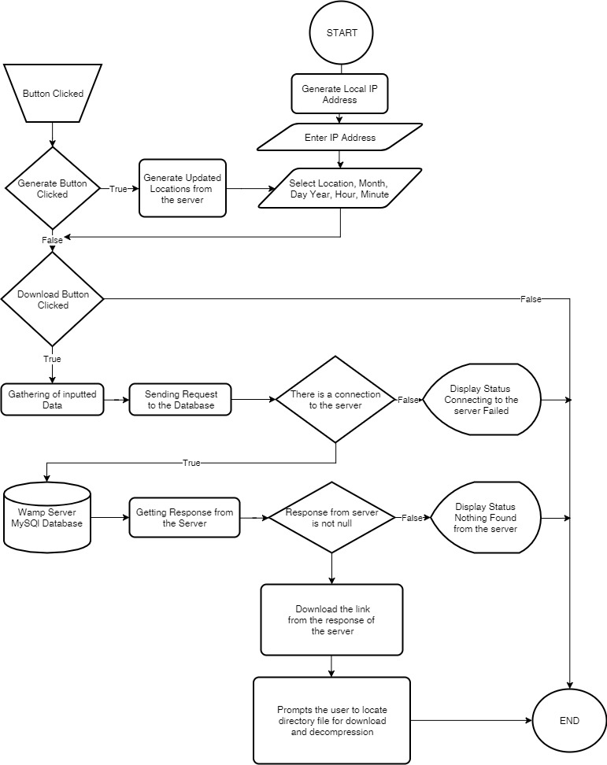
Figure 2.5.4.1 Download CSV Function
The figure above shows the flowchart of Download CSV function of Earthquake analyzer. It connects to the database and uses location as key for accessing specific data from the database.
      - Analyze X, Y, and Z Data

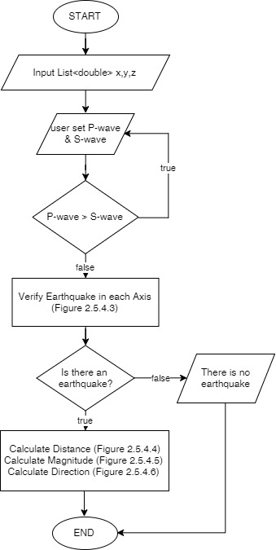
Figure 2.5.4.2 Analyze Functionality
The figure above shows the flowchart analyzing functionality on list of x, y, and z values from the CSV data after downloading it. After it has verified that there is an earthquake, it calculate distance, magnitude, and direction.
      - Earthquake Verification

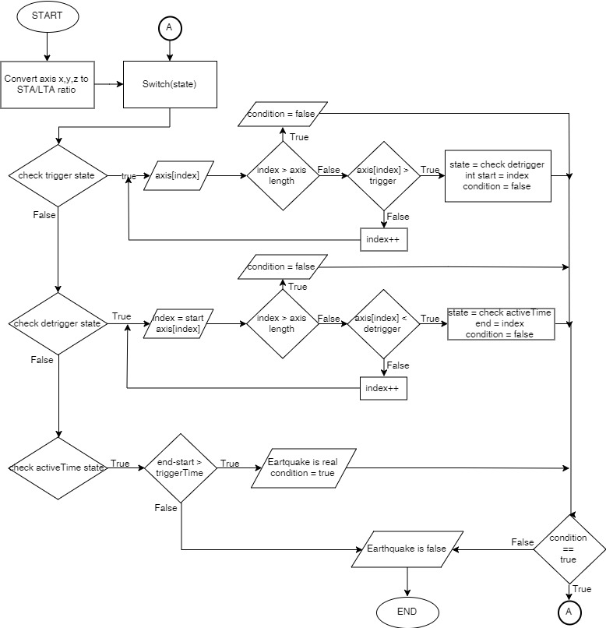
Figure 2.5.4.3 Earthquake Verification
The figure above shows the flowchart earthquake verification functionality. The function uses STA/LTA ratio method to determine if there’s a earthquake on the portion of data.

      - Calculate Distance

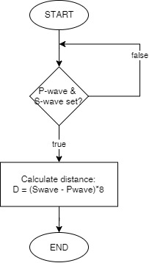
Figure 2.5.4.4 Calculate Distance
The figure above shows the flowchart of calculating distance from hypocenter.

      - Calculate Magnitude

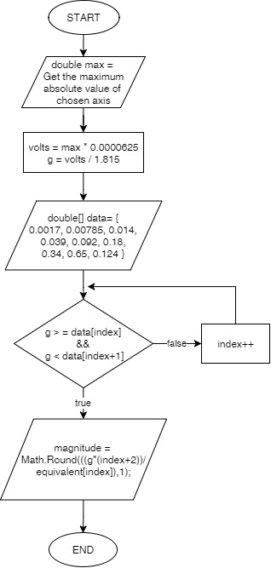
Figure 2.5.4.5 Calculate Magnitude
The figure above shows the flowchart of calculating magnitude. It uses peak ground acceleration in correlation with Mercalli Scale.
      - Calculate Direction

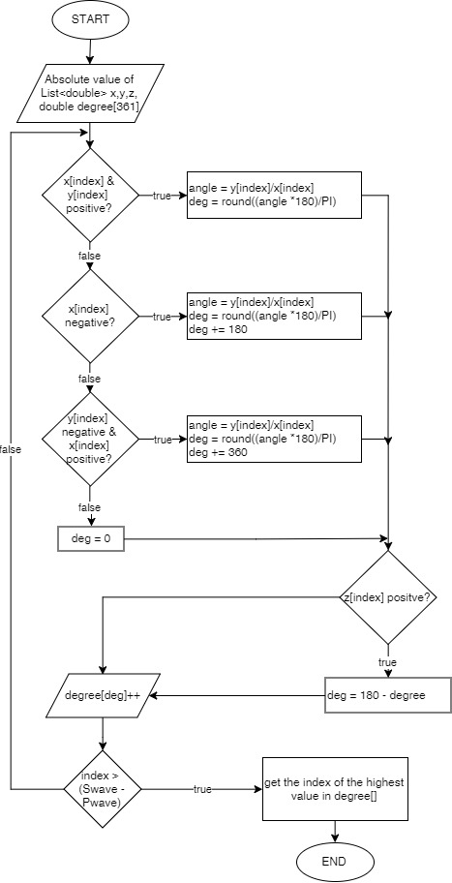
Figure 2.5.4.6 Calculate Direction
The figure above shows the flowchart of calculating direction.

  - TESTING AND DATA GATHERING
    - Testing Strategy 1: Determining the gap time in saving a file
Procedures:

- Open the Application Seismometer.
- On the upper right of the screen, press Start Service.
- Or if prompt, Input the desired data (Note: Check first the IP Address of the Database).
- Wait for a minute tick time of a clock for two minutes.
- On the upper left of the screen, press Stop Service.
- Open the .csv file in the directory file in storage/emulated/0/Samples
- Compare the two file and look for a gap time result.

The importance of gathering this data is to determine the gap time between two files for better results in analyzing the data.

Based from the data gathered, for every minute of saving a file, there is a gap time about more than 150 ms from the 1st file to the 2nd file due to some workloads that has been processed in the android. Based from the program, we discovered that it is due for some issues like the loops from recording the 3 axis data, the time, and also from opening and closing the file. Compression and Uploading the file is not the cause of the gap time between two files.

    - Testing Strategy 2: Determining the consistency in saving and compressing a file
Procedures:

- Open the Application Seismometer.
- On the upper right of the screen, press Start Service.
- Or if prompt, Input the desired data (Note: Check first the IP Address of the Database).
- Wait for a minute tick time of a clock for more than 10 minutes.
- On the upper left of the screen, press Stop Service.
- Open the directory file in storage/emulated/0/Samples and storage/emulated/0/Zip.
- Check if the naming in saving a file is in zero seconds and in every minutes.

The importance of gathering this data is to determine and prevent from having an error in saving a file. Based from the gathered data, the saving of a file is consistent and it is saving in every minute.
    - Testing Strategy 3: Determining to upload a file while the connection has been returned to its connectivity state
Procedure:

- Open the Application Seismometer and turn on the Wi-Fi.
- On the upper right of the screen, press Start Service.
- Or if prompt, Input the desired data (Note: Check first the IP Address of the Database).
- Wait for a minute to save the data to a file twice.
- Turn off the Wi-Fi.
- Turn on Again for about two minutes.
- Wait until the data has been sent to database successfully.
- On the upper left of the screen, press Stop Service.
- Open the directory file in storage/emulated/0/Samples and storage/emulated/0/Zip and Check if the file has been deleted.
- Check the data in the database if it has been successfully delivered with four files.

The importance in testing this procedure is to manage the data if the connection is lost and to send the data if the connection gets back to its state. Based from the data gathered from the database. It has been successfully uploaded continuously without any losses of file. Though if any circumstances occur if the file has not been successfully uploaded to the file it won’t be deleted in the android unless it will be successfully sent into the database.

    - Testing Strategy 4: Checking the status of Wi-Fi and connectivity to the database from the android
Procedure:

- Open the Application Seismometer and turn on the Wi-Fi.
- On the upper right of the screen, press Start Service.
- Or if prompt, Input the desired data (Note: Check first the IP Address of the Database).
- On the upper left of the screen, press the hamburger icon and Select Real Time.
- Check the icon on the lower left of the screen if the Wi-Fi icon is connected (You can try to Turn off the Wi-Fi and the icon will change to have an exclamation mark).
- Wait for a minute to save the data.
- Check if the data has been successfully uploaded (Toasted).

The importance in testing this procedure is to provide the connectivity of the phone to the router so that it can communicate to the database.

    - Testing Strategy 5: Checking the connectivity to the database from C#
Procedure:

- Open the Earthquake Analyzer Application in C#.
- On upper left window of the application, Open File>Download CSV (Prompts another window).
- Select and enter the desired input and Press Download (Note: Check first the IP Address of the Database).
- Prompts to select the saving directory for zip and .csv file
- Check the directory file if there is the saved result file in the directory file.

The importance in testing the connectivity to the database from C# is to provide data when downloading a file from the database and it will be able to analyze the data inside the file.

    - Testing Strategy 6: Testing ADXL335 sensor
Procedure:
- The ADXL was placed on the digital trainer and the supply(3.3v) and ground was connected.
- The oscilloscope probe was connected to the output x axis of the ADXL.
- Read the output on the x axis.
- Tilt the sensor forward along the x axis. Read the output.
- Tilt the sensor backward along the x axis. Read the output.
- Tilt the sensor along the y & z axis. Read the output.
- Connect the probe to the y axis and read the output.
- Tilt the sensor forward along the y axis. Read the output.
- Tilt the sensor backward along the y axis. Read the output.
- Tilt the sensor along the x & z axis. Read the output.
- Connect the probe to the z axis. Read the output.
- Flip the sensor was flipped upside down. Read the output.

This test is important because this will determine if the sensor is applicable in the design, to verify the output voltage of the sensor for the ADC, and if there are technical defects on the sensor.

    - Testing Strategy 7: Test earthquake detector method
Procedure:
- Click File -> Open, then browse for the Phivolcs csv file.
- Drag the red line in the place you want to set P-wave.
- Click the P button below the menu bar to set the P-wave.
- Drag the red line again in the place you want to set the S-wave.
- Click the S button bellow the menu bar to set the S-wave.
- Click the File->Check EQ to detect if there is an earthquake.
- Note the result.
- Open a dummy recorded csv file containing random noises.
- Repeat steps 2-7.

This testing strategy is important because, the usual way of detecting an earthquake is by waiting for the output of the sensor to reach exceed a certain threshold. This method is not efficient because what if the read data is only noise, or a sudden spike. So, the researchers used the STA/LTA method which prevent this kind of situation.

    - Testing Strategy 8: Test earthquake acceleration / magnitude
Procedure:
- Set up Digital seismometer device in a surface.
- When device is recording, create random noise to be read like stomping or punching the surface.
- Wait for the device to save and send to database.
- On the C# program, download the file in File->Download csv.
- Display the downloaded csv file in File->Open then browse the downloaded file.
- Drag the red line in the place you want to set P-wave.
- Click the P button below the menu bar to set the P-wave.
- Drag the red line again in the place you want to set the S-wave.
- Click the S button bellow the menu bar to set the S-wave.
- Click the Help->Test magnitude menu button to show the magnitude of the maximum value between the range of the plotted S & P wave.
- Refer to the Mercalli scale to verify the result.

This testing strategy is important to verify the output of the sensor is properly read by the ADC and the C# program has properly converted the counts to voltage then voltage to acceleration.

    - Testing Strategy 9: Test earthquake direction
Procedure:
- Set up Digital seismometer device in a surface.
- When device is recording, create random noise to be read like stomping or punching the surface.
- Wait for the device to save and send to database.
- On the C# program, download the file in File->Download csv.
- Display the downloaded csv file in File->Open then browse the downloaded file.
- Drag the red line in the place you want to set P-wave.
- Click the P button below the menu bar to set the P-wave.
- Drag the red line again in the place you want to set the S-wave.
- Click the S button bellow the menu bar to set the S-wave.
- Click the Help->Test direction menu button to show the magnitude of the maximum value between the range of the plotted S & P wave.
- Refer to the Mercalli scale to verify the result.

This testing strategy is important to verify if the test direction method of the C# program works properly.

    - Testing Strategy 10: Test data output accuracy
Procedure:
- Set-up Digital Seismometer device reference voltage close to 1.5V.
- Place Digital seismometer device in a flat surface.
- Set up Android Software to external source mode.
- Wait for the device to save and send to database.
- Read the contents of the csv file.
- Compare the first 60 samples of output with expected values.

This testing strategy is important to determine the average error of the output data to the expected data.

    - Testing Strategy 11: ADC common mode test
Procedure:
- Set the reference voltage of Digital Seismometer device to 1.5V.
- Set the reference pins of each ADC in common to their respective input signal pins.
- Set up Android software to external source mode.
- Wait for the device to save and send to database.
- Compare the first 60 samples of output with expected values.

This testing strategy is important to determine the factor ADC performance to the output deviation value.

CHAPTER 3

DATA PRESENTATION AND ANALYSIS

  - DATA GATHERED 1: Determining the gap time in saving a file

The importance of gathering this data is to minimize the gap time between two files for better results in analyzing the data.

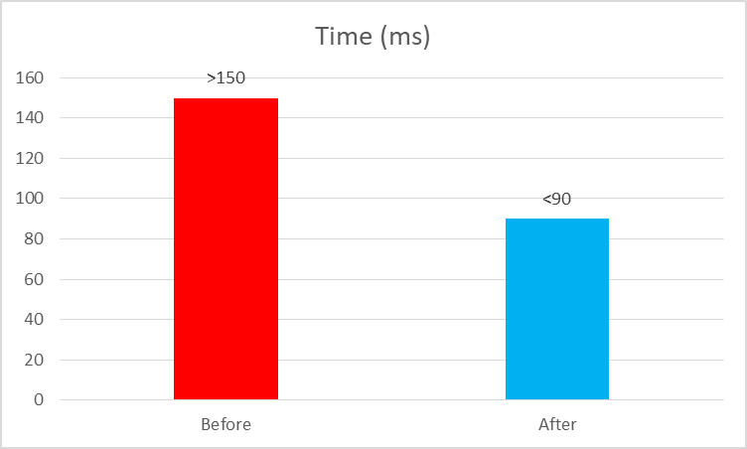
Figure 3.1 Comparing time gap after optimization

Based from Figure 3.1, we manage the program such that the loop will be disposed and changed it with a simpler one. We instead writing directly to the file instead of recording and writing it afterwards. Based from the solutions we made, there is an improving results and lesser gap time than before.

  - DATA GATHERED 2: Determining the consistency in saving a file

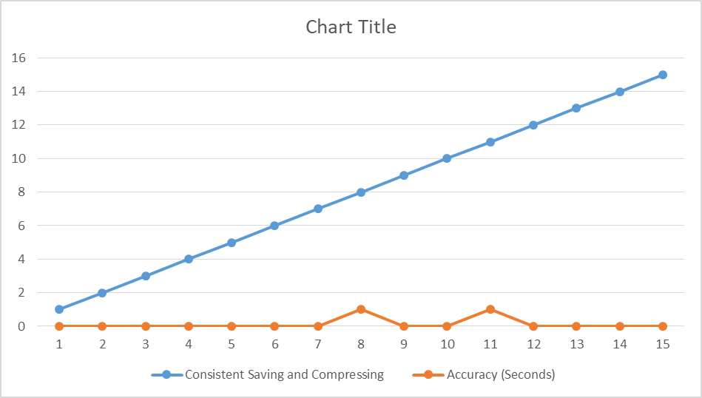
Figure 3.2 Consistency graph

Based from the graph, the consistency in saving and compressing is achieved and it is forming a straight line. The accuracy in saving a file is almost accurate in zero seconds saving 2 out of 15 has been occurred a one second time stamp in the file.

- Determining to upload a file while the connection has been return to its connectivity state
Based from the data gathered from the database. It has been successfully uploaded continuously without any losses of file.

  - DATA GATHERED 3: Start Delay of System

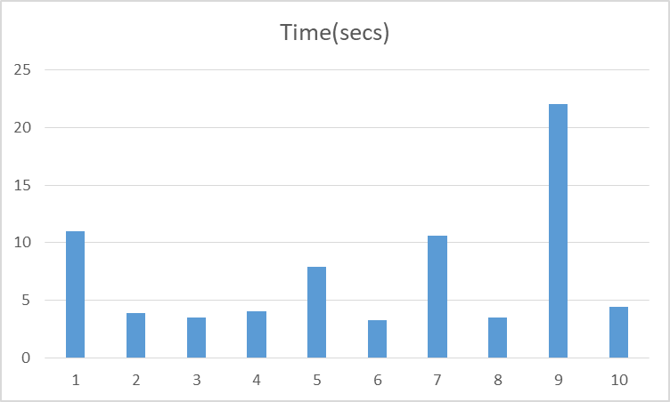
Figure 3.3 Recorded values for 10 samples

Based from Figure 3.3, the normal boot time is around 4 secs. The spike values are caused by unable to establish successful connection to the external device causing the software to re-establish connection after 5 secs. The five second delay is created in order to prevent spamming of reconnect algorithm which cause the main thread to stop.

  - DATA GATHERED 2: Degree calculation accuracy

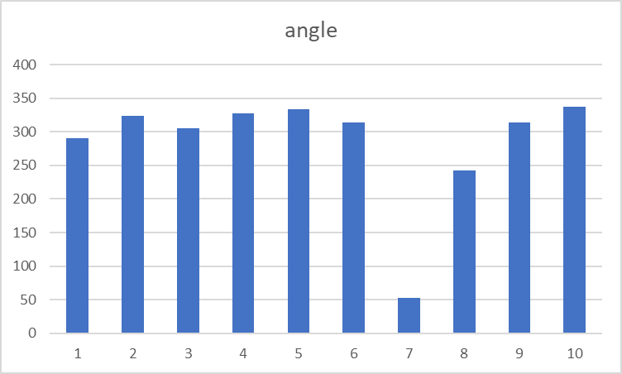

Figure 3.4 Recorded calculated degree
The researchers hit the table area at the upper left part on where the sensor was placed while the Digital Seismometer was recording. Then the recorded file was analyzed in the C# program. Based on Figure 3.4, the calculation has a good reading. The unsuccessful calculation is caused by the number of samples that are calculated. This problem can be solved by reducing the number of values to calculate the angle.

  - DATA GATHERED 5: Output Data vs Expected Data

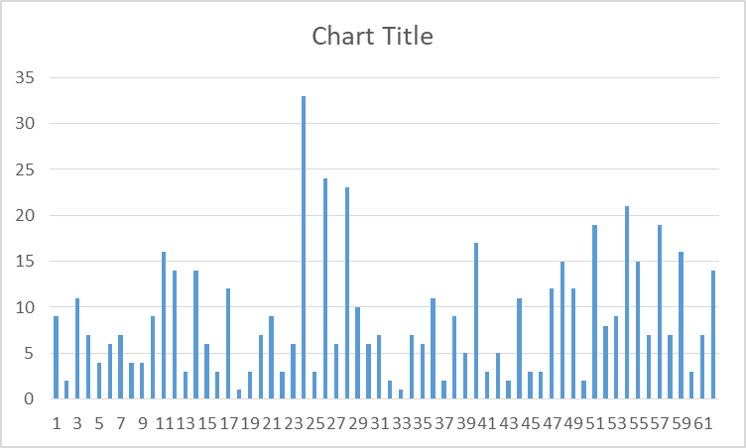

Figure 3.5 Deviation value

The figure above shows the deviation value in counts away from the expected value. The formula for getting the deviation value is the sum of all absolute value of each sample divided by the number of samples. The average deviation value is around + -8.79 or + -9 counts. The deviation value can be caused by the internal noise by the accelerometer and reference pins, and environment noise.

  - DATA GATHERED 6: Correlation of ADC Performance with Output Data

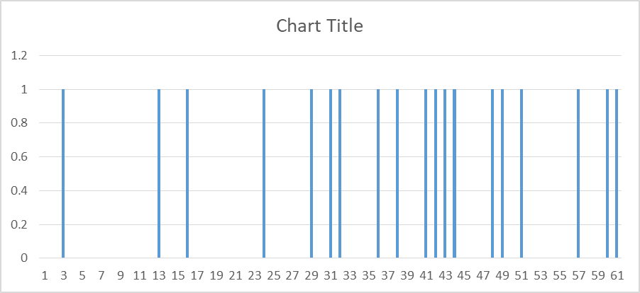

Figure 3.6 Correlation of ADC Performance with Output Data

The figure above shows the deviation value in counts away from the expected value. The formula for getting the deviation value is the sum of all absolute value of each sample divided by the number of samples. The average deviation value is around + - 0.311475. This graph pertains how less likely the ADC affects the deviation of output data.

CHAPTER 4

CONCLUSION AND RECOMMENDATION

Based on the data gathered, the digital seismometer is

REFERENCES

- https://searchmobilecomputing.techtarget.com/definition/GPRS
- https://en.wikipedia.org/wiki/Universal_asynchronous_receiver-transmitter
- https://en.wikipedia.org/wiki/Global_Positioning_System
- https://en.wikipedia.org/wiki/USB_communications_device_class
- https://earthquake.usgs.gov/learn/topics/mercalli.php
- https://www.sciencedirect.com/science/article/pii/S1738573317304564
- https://www.youtube.com/watch?v=HseRUq-IACw
- https://sciencing.com/differences-between-waves-8410417.html
- https://www.livescience.com/40102-accelerometers.html
- https://en.wikipedia.org/wiki/Accelerometer
- https://www.ncbi.nlm.nih.gov/pmc/articles/PMC4268708/
- https://is.muni.cz/th/ihit0/?lang=en

APPENDIX A
TEAM PROFILE

(Create one page profile for each member outlining the personal details. You may include a picture if you want. Please omit this italic instruction after.)

APPENDIX B
PROJECT DEVELOPMENT DOCUMENTS

Project Proposal
Approval Sheet
Work Breakdown Structure
Gantt Chart
Schedule
Attendance Monitoring Sheet

(Please attach the above documents after this sheet. Be sure that all documents are in short bond paper size. Please omit this italic instruction after.)

APPENDIX C
PROJECT DESIGN DOCUMENTS

CODES
SCREENSHOTS
RAW DATA GATHERED
DATA SHEETS

(If screenshots not applicable, please omit it from the list above.. Attached all documents listed above.
Please omit this italic instructions after)

